
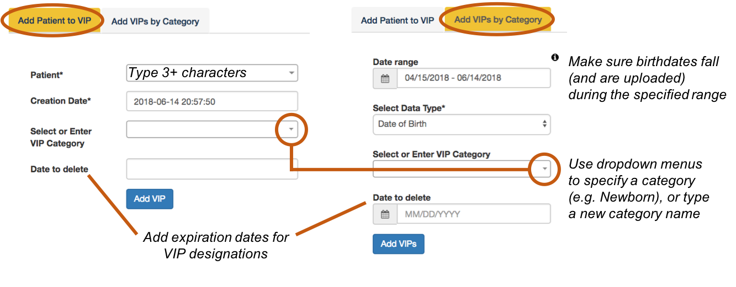
Very Important Patients (VIPs)
Add a single VIP
Add a group of VIPs
Add categories to help classify VIPs. When searching accesses, you can enter “VIP” or a category in the “General Search” box.

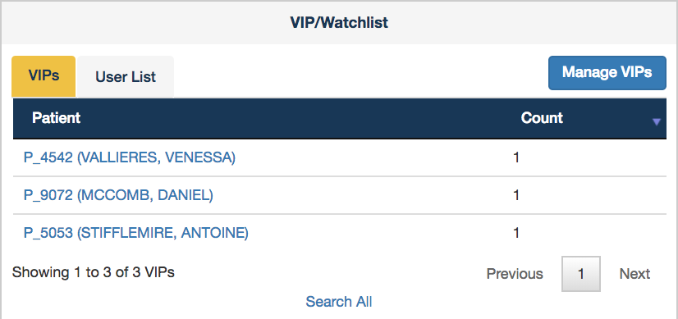
Designate certain patients as VIPs to make it easier to monitor accesses to their records. VIPs are listed on the Dashboard, along with a direct link to the VIP settings page:
Dashboard



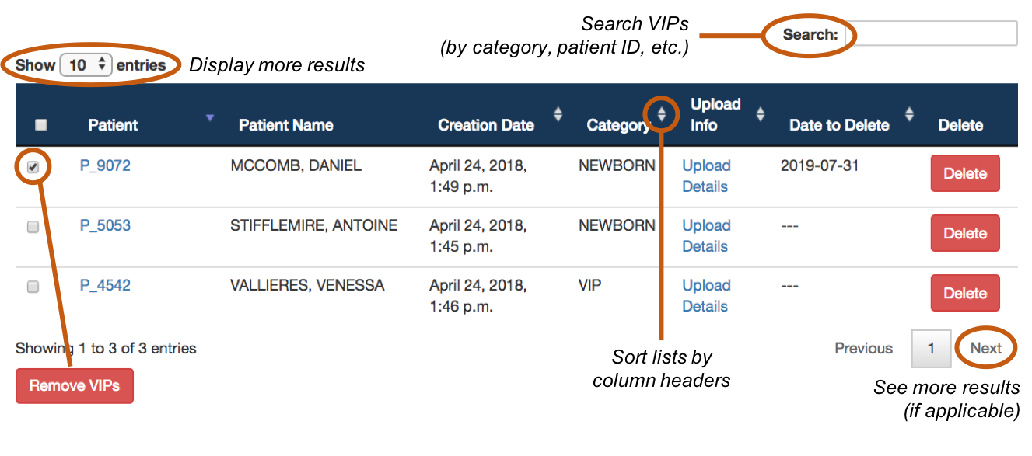
Current VIPs are listed at the bottom of the page. Navigate the list using clickable icons. Delete VIPs using the red buttons.

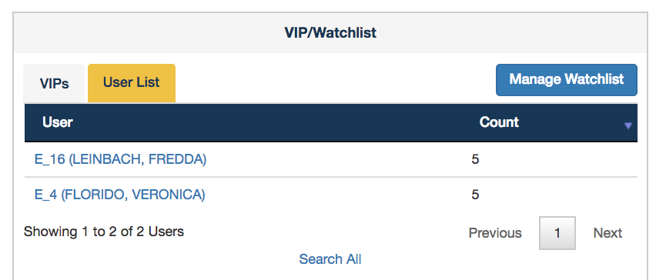
Place certain users on the Watchlist to make it easier to monitor their accesses. The Watchlist is displayed on the Dashboard, with a direct link to the Watchlist settings page:
Dashboard
Watchlist Users

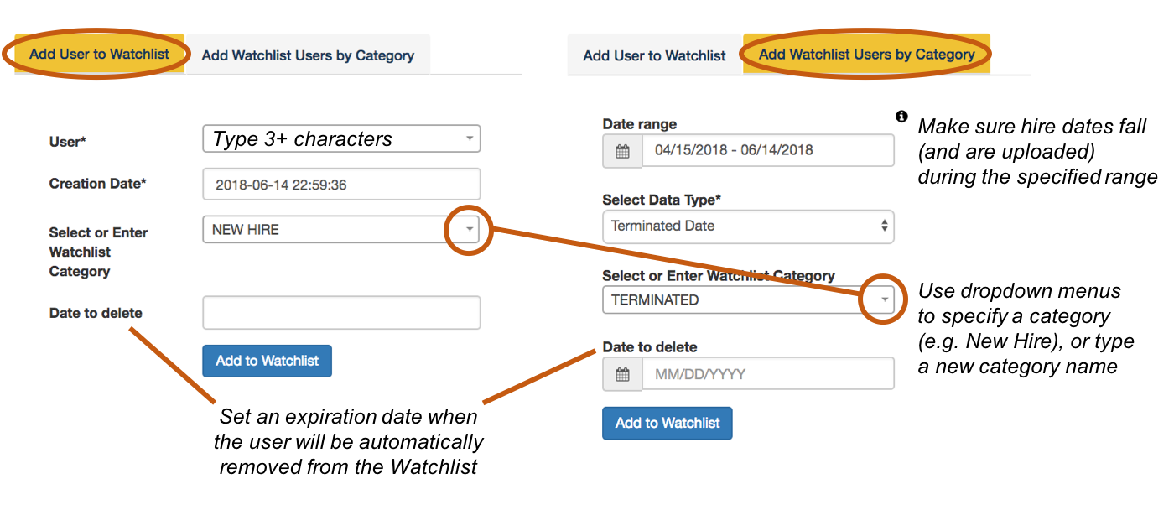
Add one user
Add a group of users
Add categories to help classify Watchlist users. Common categories include new hires or terminated employees.


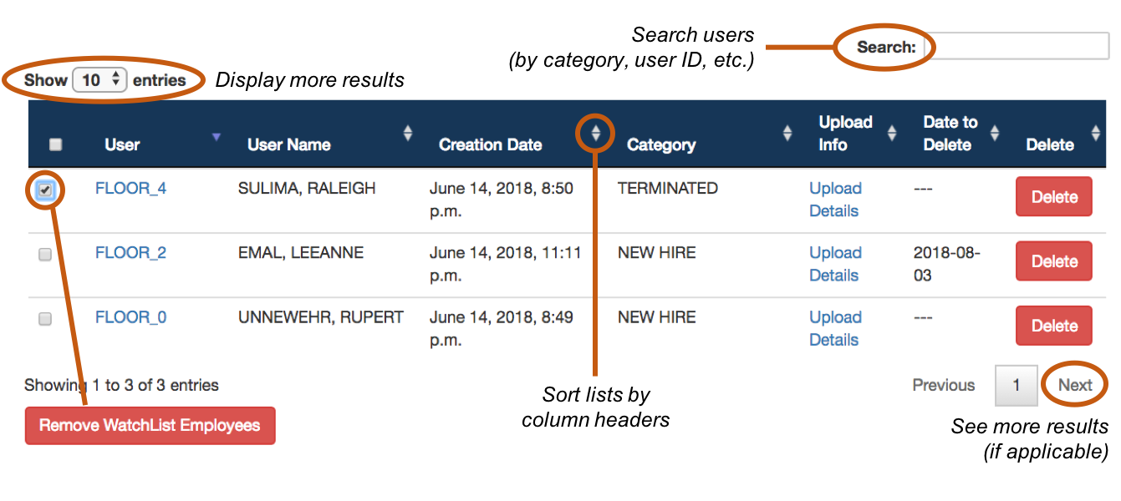
The Watchlist is included at the bottom of the page. Navigate the list using clickable icons. Delete users with the red buttons.

